APD INCIDENT REPORTING FORM
THIS DOCUMENT IS SUBJECT TO CONFIDENTIALITY REQUIREMENTS AND SHOULD BE HANDLED ACCORDINGLY. All incident reports must be complete in accordance with Chapter 65G-2, Florida Administrative Code (F.A.C.), and submitted to the appropriate APD Regional Incident Email address or via the designated incident reporting system. Incomplete reports will be sent back to the provider for corrections.

1. Demographics of Incident
Date of Incident: |  | Date Provider Became Aware:
Time of Incident: | am/pm | Time Provider Became Aware: | am/pm
County Incident Occurred: |  | Date of Initial Report:

2. Persons Involved
Name | Date of Birth | iConnect ID | Relationship to APD

3. Incident Location
Setting Incident Occurred | Name of Setting | Address
☐ Licensed Group Home
☐ Supported Living
☐ Family Home
☐ Adult Day Training
☐ School
☐ Community Based Service
☐ Other

4. Provider Notifications
Type of Notification | Name/Title | Date/Time
☐ DCF Hotline
☐ DCF Case Manager (if in DCF Custody)
☐ Law Enforcement (include Agency, Officer, and report number in details)
☐ Purple Alert Attempted
☐ Parent/Legal Guardian Notified
☐ WSC Notified
☐ ROM/Designee Notified
☐ Open Court Case (393.11/916 Forensic Cases)

5. Incident Type
Critical  Initial notification within 4 hours/Report within 1 day | Reportable  Report within 1 day
☐ Covered Person Arrest | ☐ Altercation
☐ Covered Person Injury as a result of client | ☐ Crisis Intervention Through Involuntary Commitment (Baker Act)
☐ Life Threatening Injury/Illness | ☐ Crisis Intervention Through Voluntary Commitment
☐ Media Involvement | ☐ ER/Hospitalization
☐ Missing Child/Incompetent Adult | ☐ Expected resident/Client Death
☐ Sexual Misconduct | ☐ Missing Competent Adult
☐ Suspected of Confirmed Human Trafficking | ☐ Non-Violent Crime Arrest
☐ Unexpected Resident/Client Death | ☐ Resident/Client Injury
☐ Unattended in Vehicle | ☐ Suicide Attempt
☐ Verified Abuse Report
☐ Violent Crime Arrest

6. Incident Details
Provide all details surrounding the incident. This includes events and details prior to, during, and after the incident. Incorporate the 5 W’s. (Who, What, Where, When, Why)
Click or tap here to enter text.

7. Body Diagram
Mark each area impacted during the incident.
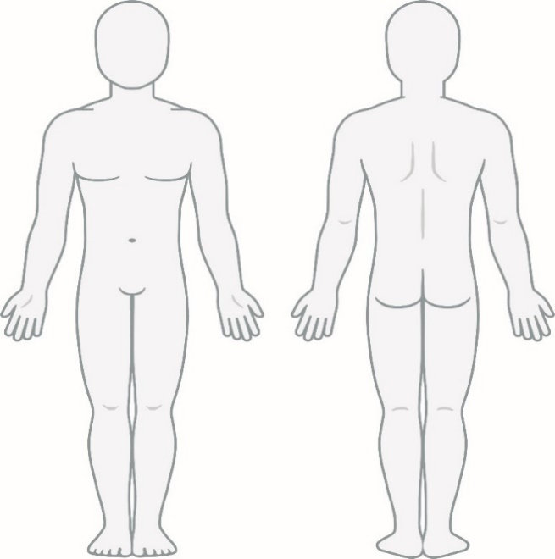

8. Provider At Time of Incident
Name of Facility or Provider: | Telephone
Address: | Email Address:

9. Initial Reporting Provider
Name of Facility or Provider: | Name of Reporting Person:
Address: | Role of Person Reporting:
Reviewing Supervisor Name: | Telephone Number:
Waiver Support Coordinator: | Telephone Number:

10. Follow-Up Details
This section may be completed at a later date, not to exceed five days.
Follow-Up | Date of Follow-Up
☐ 1st Follow-Up
☐ 2nd Follow-Up
☐ 3rd Follow-Up

11. Provider Implemented Corrective Action Plan

12. Causes and Contributing Factors

13. Preventative Measures

14. Outline Follow-Up Actions Taken for Individual
This includes legal, medical, behavioral, therapeutic, environmental, support, equipment, or other actions.

15. Follow-Up Reporting Provider
Name of Facility or Provider: | Name of Reporting Person:
Address: | Role of Person Reporting:
Reviewing Supervisor Name: | Telephone Number:
Waiver Support Coordinator: | Telephone Number:

