**How to use the APD Medication Administration Record (MAR)**

What is the MAR used for?

The MAR is where medications given to a client are documented. Used correctly, the MAR records:

* who the medications were given to
* what medications were given
* what dose of medication was given
* when the medication was given
* what route the medication was given by
* any instructions for giving the medication
* why they were given if a PRN (as needed) medication
* the effectiveness of PRN medications
* any medication that was not given as ordered, including why it was not given
* any reaction to new medications
* who gave each medication
* who ordered each medication
* client allergies

The MAR helps you to stay organized when giving clients their medications.

The MAR is a required document – it must be used for any APD client who is receiving assistance with their medications! Sometimes you will use a MAR provided by a pharmacy, or you will document medications electronically using a computer. All of these different MARs must have the same elements as the APD MAR.

**The goal is to accurately document every medication you give.**

**How to fill out the MAR**

**WHO** the medications are given to – fill in the “Name” blank at the top of the MAR, along with the month and year.

**CLIENT ALLERGIES** – Fill in the “Allergies” blank found under the name and month/year. If you are using an alternate MAR, make sure you know where allergies are recorded.

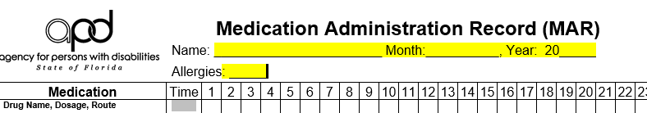

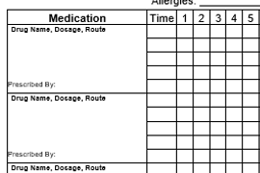

What medication

What dose (how much?)

What route (sometimes includes where)

When (what time, how often, how long)

All of these are written in these boxes, under “Medication”

The entry should be written as the prescriber wrote it except for most abbreviations. A list of these can be found at the end of this tutorial for reference.

The information in the Medication box should be given in a standard format. Here are a few examples:

Verapamil SR 180mg, 1tablet by mouth every morning

Latanoprost 1% 1 drop in each eye at bedtime

Amoxicillin suspension 250mg/5ml, give 10ml per PEG tube 3 times daily for 10 days.

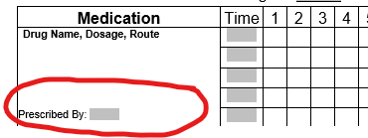

The name of the person who prescribed the medication is also in the “Medication” box. You should write the date the prescription was written after the name. For example, Prescribed By:

Lucy Lundquist, APRN 5/19/20

Sara Flannery, MD 7/5/19

Jacob Marks, DO 12/20/18

You will find that sometimes an older date will be written next to the name of the prescriber. This is usually the original prescription date, and is ok to use. It is also acceptable to use the latest date the prescriber re-wrote the prescription – as would usually happen at an annual check-up - for a long-term medication

Another thing you may find in the “Medication” box is instructions for giving the medication. Some examples of this are:

Crush medication and give in applesauce or pudding

Dilute liquid medication in 10ml water

Crush medication and dissolve completely in 10ml water

Cover ointment with large Band-Aid

Do not consume milk products for 2 hours after taking this medication

Sometimes a medication is ordered “as needed” or “PRN.” This means that you give the medication only if specific conditions are met. Some examples of these conditions might be:

Give for fever of 101°F or greater

Give for complaint of headache or pain

Give if client has not had a bowel movement for 3 days

Give for anxiety, as evidenced by pacing or loud vocalizations

Apply to any abrasions to arms after cleaning with soap and water

ALL PRN orders must also state how often the medication can be given, the maximum number of doses that can be given in a specified time period, and conditions for which the prescriber must be called. A complete PRN order might read:

Tylenol 325mg tablet, give 2 tablets by mouth every 4 hours as needed for fever of 101°F or greater. Give no more than 6 times in 24 hours, call MD if fever persists longer than 48 hours.

When you give a PRN medication, you MUST turn the MAR over and record WHY you gave it on the back of the MAR. You also must come back to that entry later and document the client’s response to the medication.

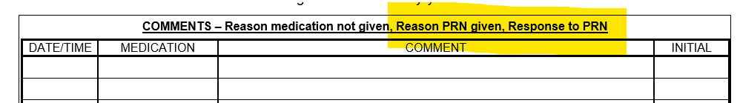

Now we’ll take a look at some MAR examples for different situations.

**NEW MEDICATION – INCREASING DOSE**

We will begin with this prescription for Mark Frye, who is allergic to penicillin:

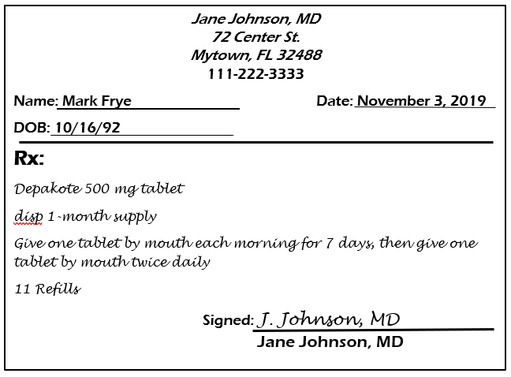

You will often see the term “**Rx**” on prescriptions – it means “prescription”

Start by writing Mark’s name and allergies at the top of the MAR, along with the month and the year.



Looking at this new order for Mark, you can see that there is one medication ordered – but 2 different dosing schedules. This means you will need to write out the information on the MAR twice.

1. write the medication name on each of two lines:

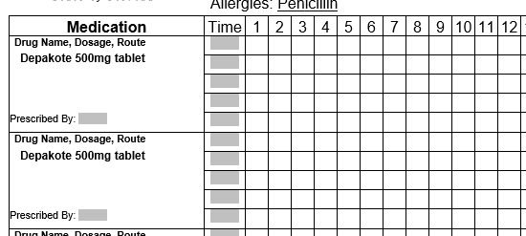

1. Then, write out each set of directions. Remember to always write out the route for the medication, how often it is taken each day, and how long the client should take the medication before stopping. If the prescription doesn’t have a stop date or length of time, that means the medication should be taken as ordered until you get another order to stop the medication. You can also add the name of the prescriber and the date at this time.

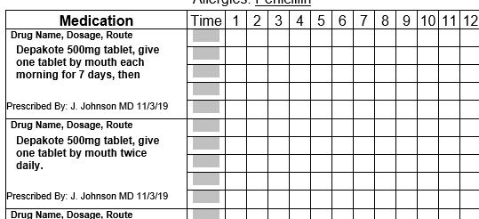

1. Next, you have to figure out the start date for each dose and the time it is given
   1. For the first week, the Depakote is to be given only once a day, in the morning – so you would start the next day, the 4th of November. The order says ‘morning’ so we will use 7am.
   2. The twice a day dose schedule starts 7 days later, so the starting date for that would be the 11th of November. For this example, we will schedule the evening dose at 7pm.
   3. You will need to mark out the days before the start date for each entry, and also mark out the days after the once-a-day dose stops. **\*Never completely black out spaces on the MAR – only line through them.**
   4. You can put the start dates or date ranges in the medication box if you want to, to help you keep track.

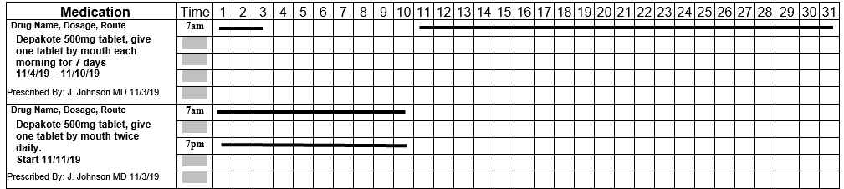

1. The next thing you MUST do, before you begin to give the medication, is to go to the bottom of the MAR, and in the spaces provided print your name, sign your name, and initial. It is a good idea to turn the MAR over and also enter this in the space provided on the back of the MAR.

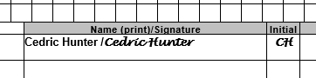

Since Cedric probably doesn’t work every day, we have also added Anna and Mario to help him give medications:

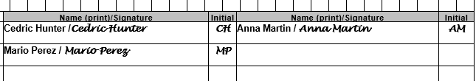

1. Let’s take a look at how Cedric, Anna, and Mario will document giving Mark his medication over the next week or two:

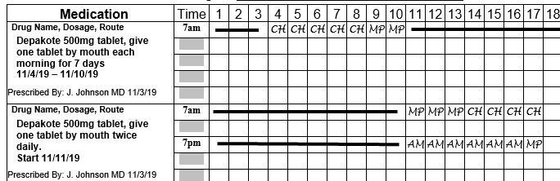

You can see that Cedric, Mario, and Anna initialed each time they gave a dose of Depakote to Mark.

**IT IS VERY IMPORTANT TO DOCUMENT THE MEDICATIONS YOU ASSIST WITH RIGHT AFTER YOU GIVE THEM. DON’T WAIT UNTIL LATER.**

1. EVEN THOUGH you have put a line to indicate that Mark’s once-a-day dose ended on the 10th – once you are no longer giving this medication only one time per day (on the 11th, in this case), the entire set of boxes should be marked over with a yellow highlighter, and the word ‘changed’ written, with the date and your initials. This makes it obvious that this medication order is no longer in effect:

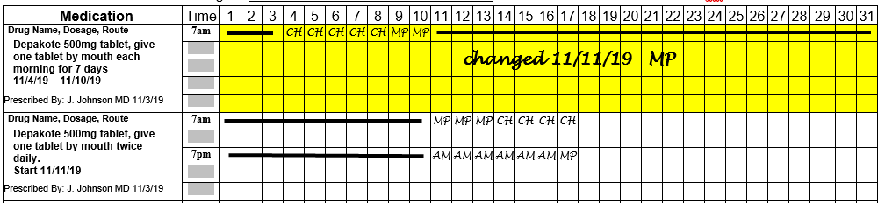

Here is another example of a medication being changed – in this case, a medication that a different client had been taking a long time. The APRN has changed the dosage on the Clonidine from 0.2mg every 12 hours to 0.1mg every 12 hours.

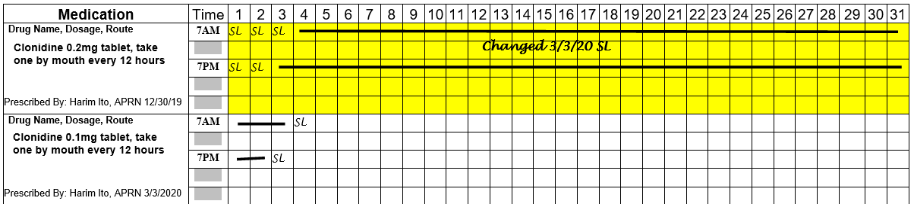

Notice that the old dose (0.2mg) was given in the morning, and the new dose (0.1mg) was given in the evening.

**DOCUMENTING NEW AND MISSED MEDICATIONS ON THE BACK OF THE MAR**

1. There are a few more things to pay attention to with Mark’s new order for Depakote:
   1. This is a new medication for Mark – he must be observed for at least 20 minutes after each of the first three doses – and this observation must be documented on the back of the MAR.
   2. Mark refused his evening dose of Depakote on the 14th – this must be documented – first by initialing and circling the entry on the front of the MAR, and then documenting the refusal on the back of the MAR. You will also need to fill out a medication error report for the missed medication.

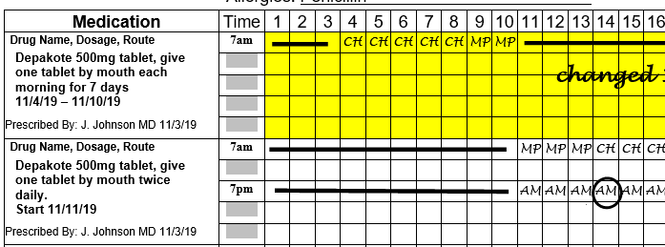

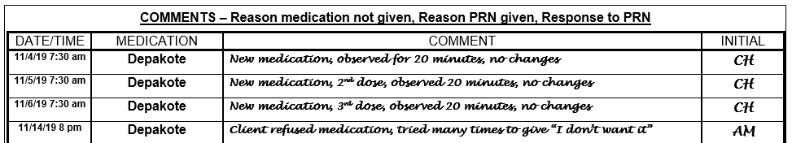

Here, you can see that Anna documented that Mark refused his 7PM Depakote at 8PM. Although the medication was scheduled for 7PM, she had a 1-hour window before and after that time for giving the medication, and did not document the refusal until the end of that period.

**NEW MEDICATION – NOT GIVEN EVERY DAY**

Now that we have seen how to fill out a MAR for a new medication that changes after one week and is given daily or twice daily, we will look at an order for a medication that is not given every day.

On the 17th of November, you tell the APRN at Mark’s primary care clinic that he is having problems with constipation. He writes a prescription for Milk of Magnesia.

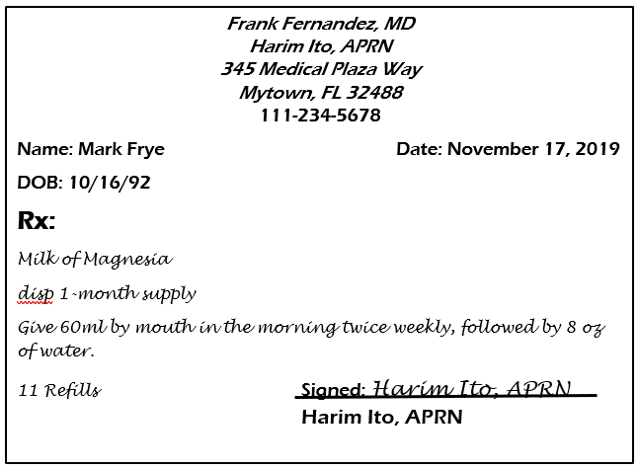

1. Start by putting the name of the medication “Milk of Magnesia” on the MAR

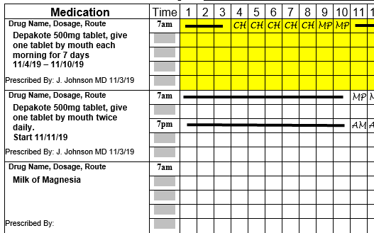

1. Next, add the dose – 60ml – and the instructions. You may also add the start date if you want to:

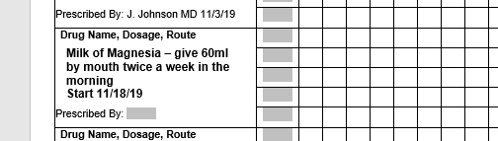

1. Next, you will want to add the time for the morning dose. Since Mark is already getting medication at 7AM, you can schedule it for then. You can also add the name of the APRN and the date the prescription was written:

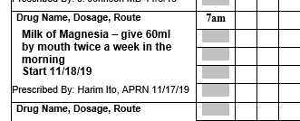

1. To fill out this MAR, you would need to know that 11/18/19 is on a Monday, so to give this medication twice a week you would give it on Monday and Thursday. When you have a medication that is given on particular days of the week, it is sometimes helpful to write the abbreviations for the days above the numbers (abbreviations are ok here, since it is only to show the day of the week):

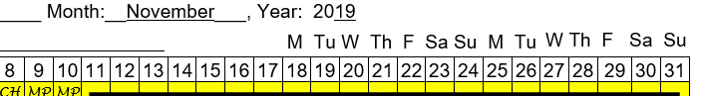

1. Now you have to fill out the MAR chart to show when to start the medication, and to block off the days it is not to be given:

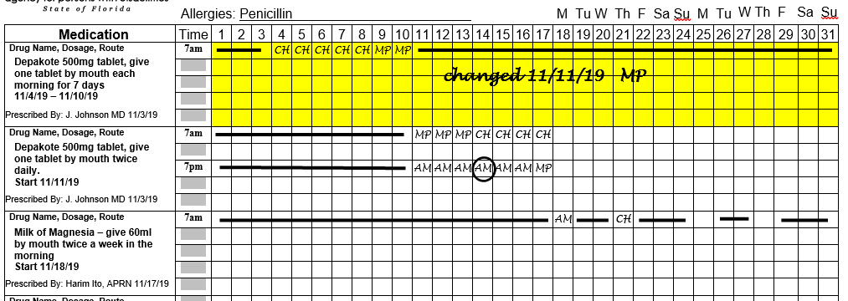

You can see here that the only squares open to write in for this medication are Mondays and Thursdays.

1. Here are the entries made when Anna and Cedric give this medication the first two times:

Front of the MAR

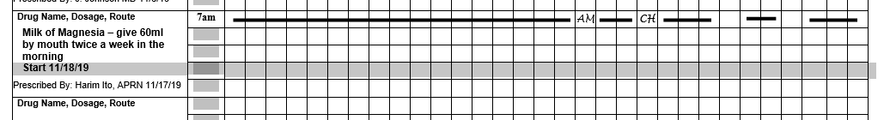

Back of the MAR

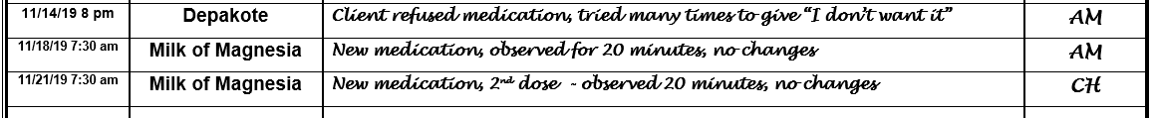

**Remember,** the 20-minute observation will also need to be done the 3rd time the medication is given.

**AS NEEDED MEDICATIONS (NOT SCHEDULED)**

Next, you will learn how to fill out a MAR for medications that are only given “as needed.” The abbreviation you often see for this is “PRN,” which stands for “pro re nata” in Latin. You should always write “as needed” on the MAR.

Here is an order for Felicia Angeles:

*Frank Fernandez, MD*

*Harim Ito, APRN*

*345 Medical Plaza Way*

*Mytown, FL 32488*

111-234-5678

Name: Felicia Angeles Date: Feb 3, 2020

DOB: 4/12/86

**Rx:**

Tylenol (Acetaminophen) 325mg tablet

Give 2 tablets by mouth every 4 hours as needed for complaints of pain or for fever of 101° or greater. Give no more than 6 times in 24 hours. Call MD or APRN if pain or fever persists longer than 48 hours.

Signed: Harim Ito, APRN Harim Ito, APRN

*Note that this order is written for pain or for fever – this is ok for Tylenol, ibuprofen and the like. For narcotics or stronger drugs, it is best if the order is written for a specific condition – pain in left arm from fracture, mouth pain related to abscess, post-operative abdominal pain, for example.*

1. Here is this order written on the MAR. Note that two ‘Medication’ spaces on the MAR were used. This is because you will need many more spaces to record the time if the client takes this medication often. As you get to know your clients, you will learn how many spaces to use.

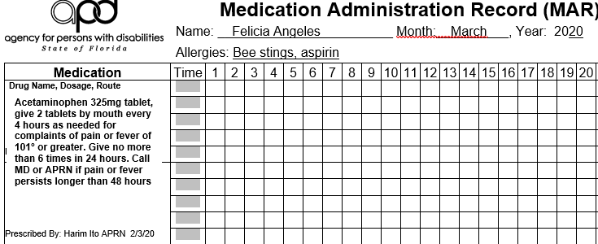

**ALL** ‘as needed’ orders must have certain extra elements included in order for a MAP to give them. These are (with elements from the above order for reference):

The reason the medication is ordered (for complaints of pain or fever of 101° or greater)

The maximum number of days that the medication should be given (if pain or fever persists longer than 48 hours – so 2 days)

The maximum number of doses per day (Give no more than 6 times in 24 hours)

Conditions under which the healthcare provider must be notified (if pain or fever persists longer than 48 hours)

1. On March 3 at 10am, Felicia is complaining of a headache. Cooper looks at the MAR and notes he can give her some Tylenol. This is how he would document it on the front and the back of the MAR (note that this is not the 1st, 2nd, or 3rd time Felicia has taken this medication)

Front of the MAR

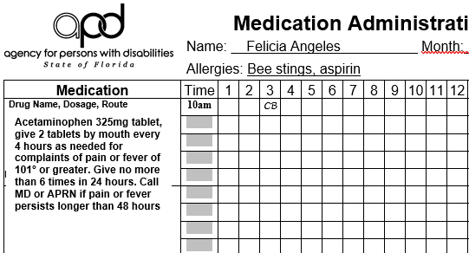

Back of the MAR

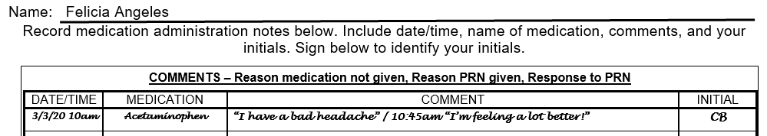

Cooper could have written that Felicia was complaining of a headache. Writing down exactly what the client said is short and to the point, and often a better way to do this. Also note that Cooper checked on Felicia within an hour and reported the results of the PRN medication. **Reporting on the result of the PRN is required.**

1. When documenting something that is tied to a measurement, like a fever, always be sure to document what the measurement is. Here, Felicia had a fever on March 8th, and got Acetaminophen three different times. The front of the MAR looks like this:

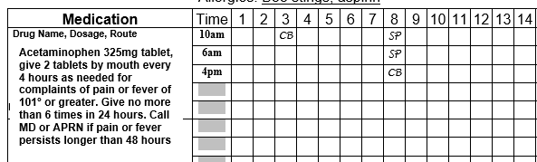

Note that Saralyn gave the 1st dose at 6am, and then gave another dose at 10am. She saw that there was already a row on the MAR for the 10am time for this medication, so she initialed there. It is a little confusing – it may help to remember that there is only one of any particular time in a 24-hour period – even though it looks odd to document the 10am above the 6am. It is still accurate, and keeps you from adding more lines for the same time.

4. Those that do not like putting the times on the front of the MAR for as needed medications may leave the time area blank on the front and fill it in only on the back of the MAR, like this:

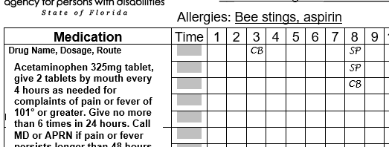

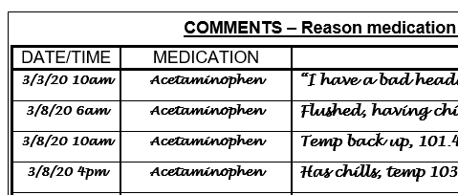

**PLEASE NOTE that either way of recording the time given is acceptable.**

5.The back of the MAR looks like this no matter which way you record the time given. Notice how Saralyn and Bennett both wrote down the temperature when they gave the medication and then when they checked it again a little while later.

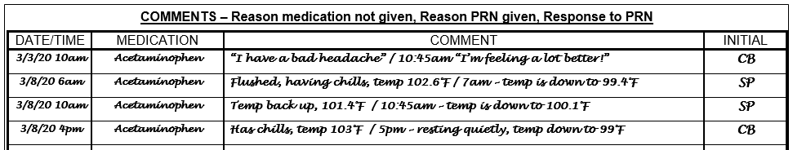

**LIMITED TIME ORDERS**

Next, we will look at how to document medications that are only given for a limited time.

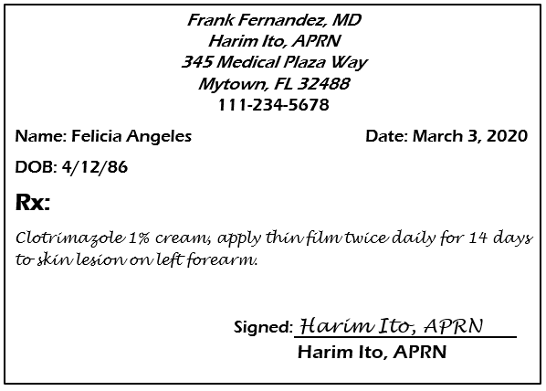

1. After checking the prescription against the medication label to make sure you have received the right medication, you must enter this on Felicia’s MAR in a way that clearly shows the medication starts and stops. Since the medication was ordered late in the day on the 3rd, you will start this medication on the 4th.
2. First, you will write the order on the MAR, including the name of the prescriber:

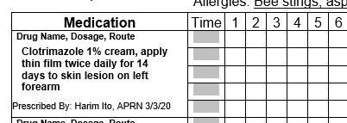

1. Second, you will write in the times you will give the medication:

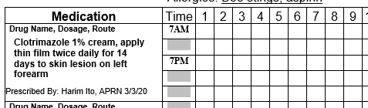

1. Third, you use lines on the MAR to indicate when this medication starts and stops. Since it is starting on the 4th, and needs to be given for 14 days, the last day to give it would be the 17th:

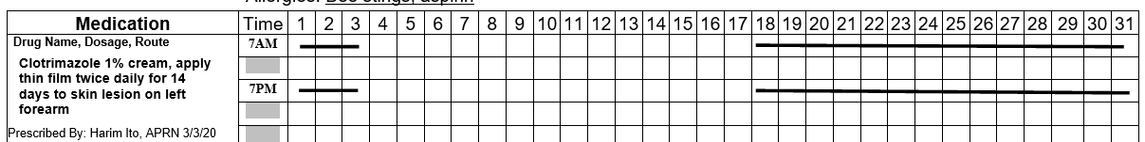

As you can see, the medication clearly starts on the 4th, and is not given after the 17th. Anyone trying to document after the 17th would not have a place to write their initials. This is very important with medications like creams, lotions, or shampoos, because there is often medication left in the tube or bottle when the time for giving it is over. With medications like antibiotics that are given for an ordered number of days, the pharmacy only dispenses enough medication for that time period, so there are no extra doses to give. However, all medications ordered for a limited time are written on the MAR exactly like this, whether there is a supply of the medication left over or not.

You should pay special attention to limited time orders if you are using medications out of a stock bottle, and not a client specific supply. If you are using stock for an order that reads, “Ibuprofen 800mg by mouth every 12 hours for 3 days,” you will not run out of medication – but you must not give the medication that way for more than 6 doses, or 3 days.

You do not need an order to discontinue a time-limited order. The date to stop the medication is in the original order.

**DISCONTINUING MEDICATIONS**

The last thing you need to learn about MAR documentation is how to discontinue a medication on the MAR. In this case, Felicia has been taking Spironolactone 25mg tablet by mouth each morning for several years. Her APRN has sent you an order to discontinue it on March 9, 2020, after Felicia took the medication that morning - so you will discontinue starting the 10th:

1. First, you will draw a line through the remaining boxes, and then you will write “discontinued 3/10/20” underneath, adding your initials:

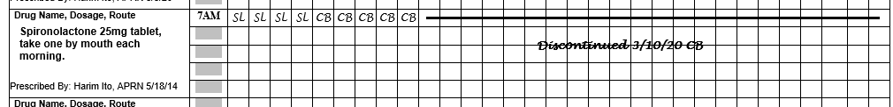

1. The last thing you will do is highlight the entire block for this medication with a yellow highlighter to alert everyone that the medication has been stopped:

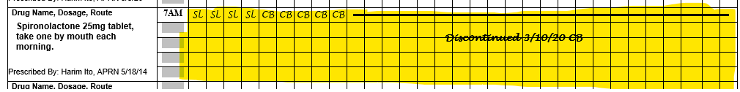

Reminder: do not draw a thick black line, cross out or otherwise make **any** previous entries on the MAR unreadable.

**PRACTICE!!**

Once you have learned all of these skills, you will be able to use the MAR with confidence! Here are a few orders to practice with, using a blank MAR, for a client named John Mason (allergic to Topamax). Leah Ruen, MD orders his medications. The month is May 2020.

1. Current medications are (fill these out on the MAR – all ordered October 10th, 2019):
   1. Pepcid 20mg tablet by mouth each morning
      1. document giving for the month
   2. Metamucil one scoop mixed in 8 ounces of water by mouth each morning
      1. document giving until May 14 – then follow directions at #3
   3. Xanax 1mg tablet every 8 hours by mouth as needed for anxiety as evidenced by bouncing on toes or repeated vocalizations. Give no more than 2 doses in 24 hours, call MD if not effective after 2 doses.
2. On May 3rd, John received an order for Lithium 300mg tablet – give one tablet by mouth each morning for 14 days, then increase to two tablets by mouth each morning.
   1. enter the medication order on the MAR, to start on May 4th
   2. document giving the medication for the rest of the month, including entries to the back of the MAR that are needed
   3. on the 12th, John refuses the medication, saying, “I’m too sleepy”
3. On May 14th, Dr. Ruen discontinues the Metamucil
   1. discontinue the Metamucil on the MAR
4. Also, on May 14th, Dr. Ruen orders Amoxicillin 500mg tablet by mouth 3 times daily for 10 days.
   1. enter this medication on the MAR, to start with the evening dose on the 14th
   2. make sure you can tell when the medication starts and stops on the MAR for each time it is given
   3. document giving this medication for the rest of the month, including any entries to the back of the MAR that are needed
5. On May 20th, you notice that John is bouncing up and down on his toes and repeating the word “yellow.” Check your orders to see if he has a medication ordered for anxiety.
   1. document giving this medication on the front and the back of the MAR
   2. make sure to document how John is doing later – within an hour
6. On May 25th, you tell Dr. Ruen that John hasn’t had a bowel movement for several days. She gives you an order for Miralax powder, 17 grams (fill bottle top to line) mixed with 8 ounces of liquid. Give by mouth twice a week, in the morning. May 25th is a Monday.
   1. enter this medication on the MAR
   2. mark the MAR to show which days it is given
   3. document giving the medication for the rest of the month, including on the back of the MAR, as needed

**DID YOU REMEMBER TO WRITE YOUR NAME, SIGN YOUR NAME, AND ENTER YOUR INITIALS AT THE BOTTOM OF THE MAR ON BOTH SIDES?** IF NOT – DO THAT NOW.

**Common Prescription Abbreviations**

The following chart includes a list of some common medical abbreviations. They are used daily in medicine as “medical shorthand,” but less often in writing prescriptions – electronic ordering by prescribers has decreased their use somewhat – but you will still see them.

|  |  |
| --- | --- |
| **Abbreviation** | **Meaning** |
| a.c. | Before meals |
| BID | Twice a day |
| cap | capsule |
| D/C or d/c | Discontinue (do not use) |
| gtt | drop |
| H.S. or h.s. | Hour of sleep, or bedtime |
| mg | Milligram |
| ml | Milliliter |
| od | Right eye |
| os | Left eye |
| ou | Both eyes |
| po | By mouth |
| p.c. | After meals |
| pr | Per rectum |
| prn | As needed |
| QD | Daily, once per day |
| QOD | Every other day |
| Tab | Tablet |
| Q3h | Every 3 hours |
| QID or qid | Four times daily |
| s.l. | Sublingual, under the tongue |
| TID or tid | Three times daily |
| U or u | Units |

When you are writing an order on the MAR, you should not use the abbreviations. While some health care practitioners still use them, many do not, because abbreviations have been identified as the main cause of many medication errors. They can be very confusing! For instance, it is better to write out “daily” than to use “QD,” which is easily confused with “QID” or “QOD.” “PO,” “pc,” “pr,” and “prn” look very similar, but mean very different things. If you have ANY doubt about an abbreviation, call the prescriber or pharmacist and make sure you have the correct understanding before entering the medication on the MAR.